Prepare Multiple Nodes on Alibaba Cloud

1.1. Purchase Single Node on Alibaba Cloud
Step 1: Click https://homenew.console.aliyun.com/home/dashboard/ProductAndService, choose the ECS service,
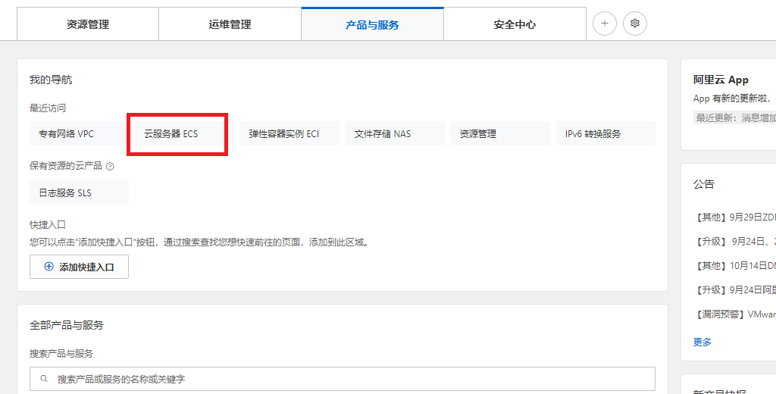
Step 2: Create a new instance, choose pay as you go, choose ecs.c7.2xlarge, choose Ubuntu 16.04 64 bits, choose ESSD, choose no IPv4 address, choose your password Y0urpassword,
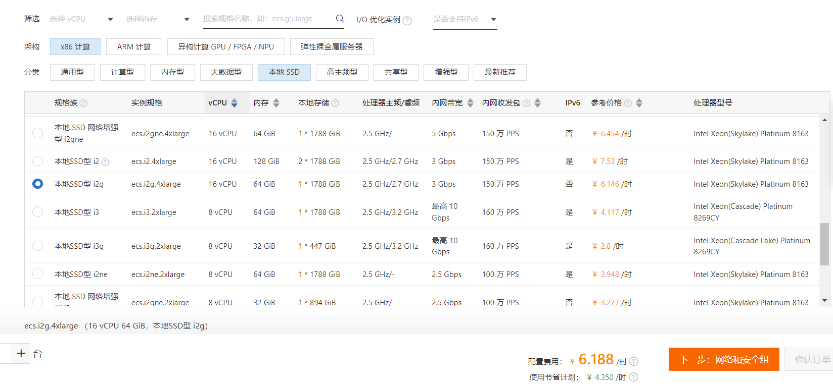
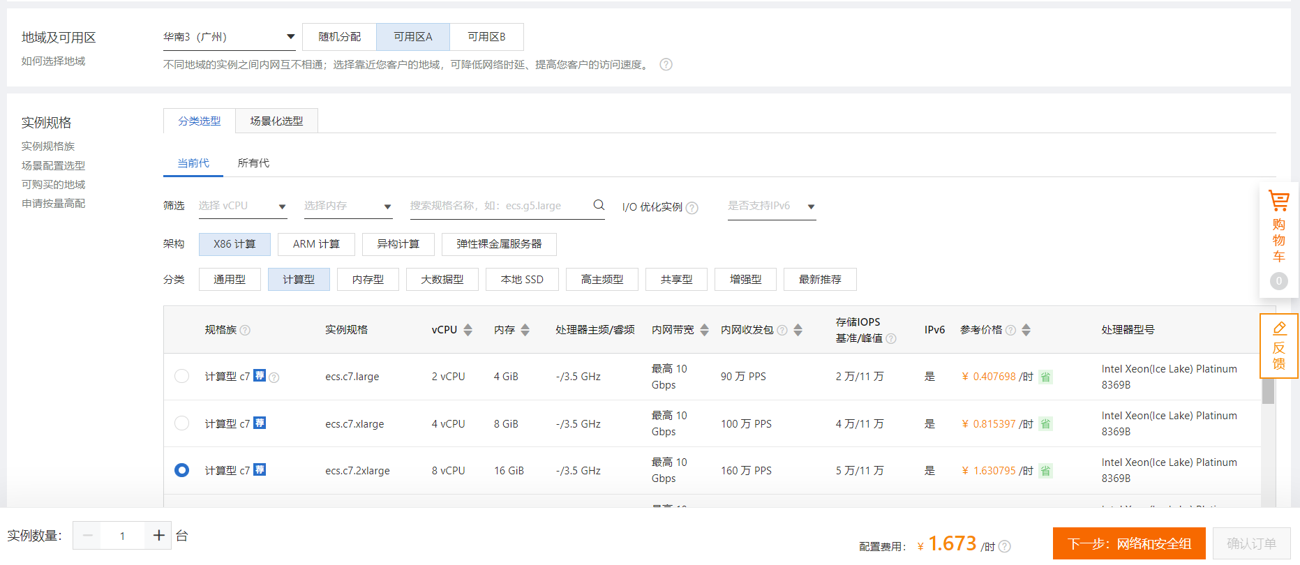
Step 3: Double-check the order,
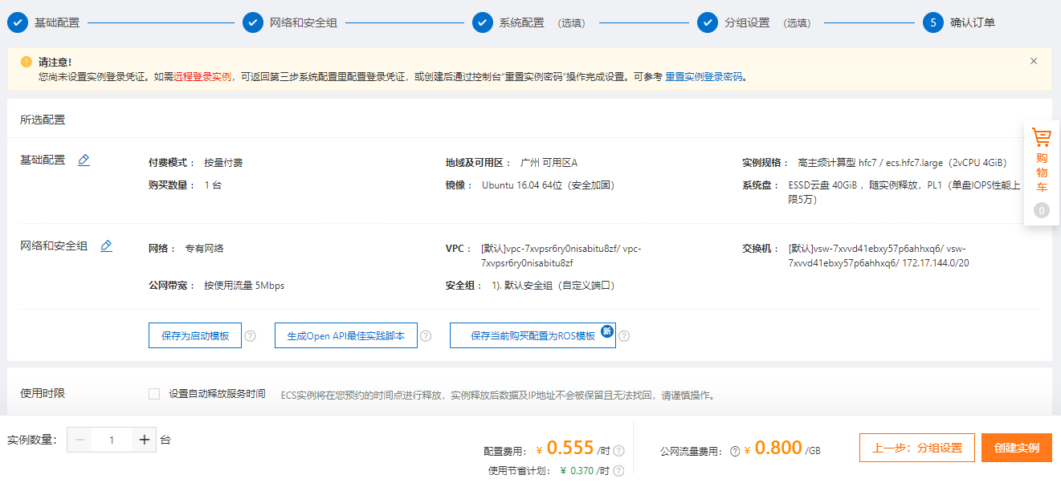

Step 4: Pay the order,
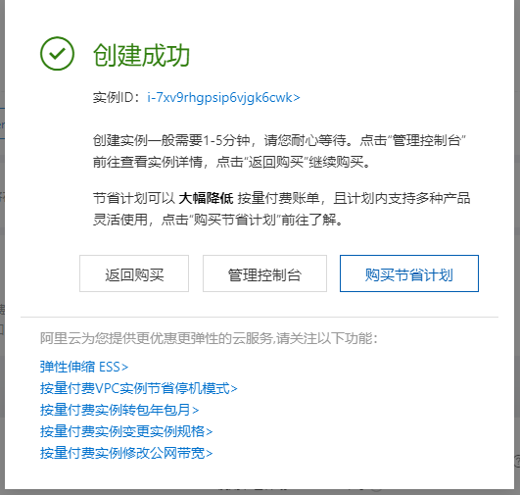
Step 5: Access the ECS instance via Alibaba Workbench, where the default username is root,
So far, the ECS instance cannot access the Internet because it has no IP address.

1.2. Purchase a NAT Gateway

Step 1: Click https://vpc.console.aliyun.com/nat/cn-shenzhen/nats, purchase 2 public IP addresses, create a NAT gateway,
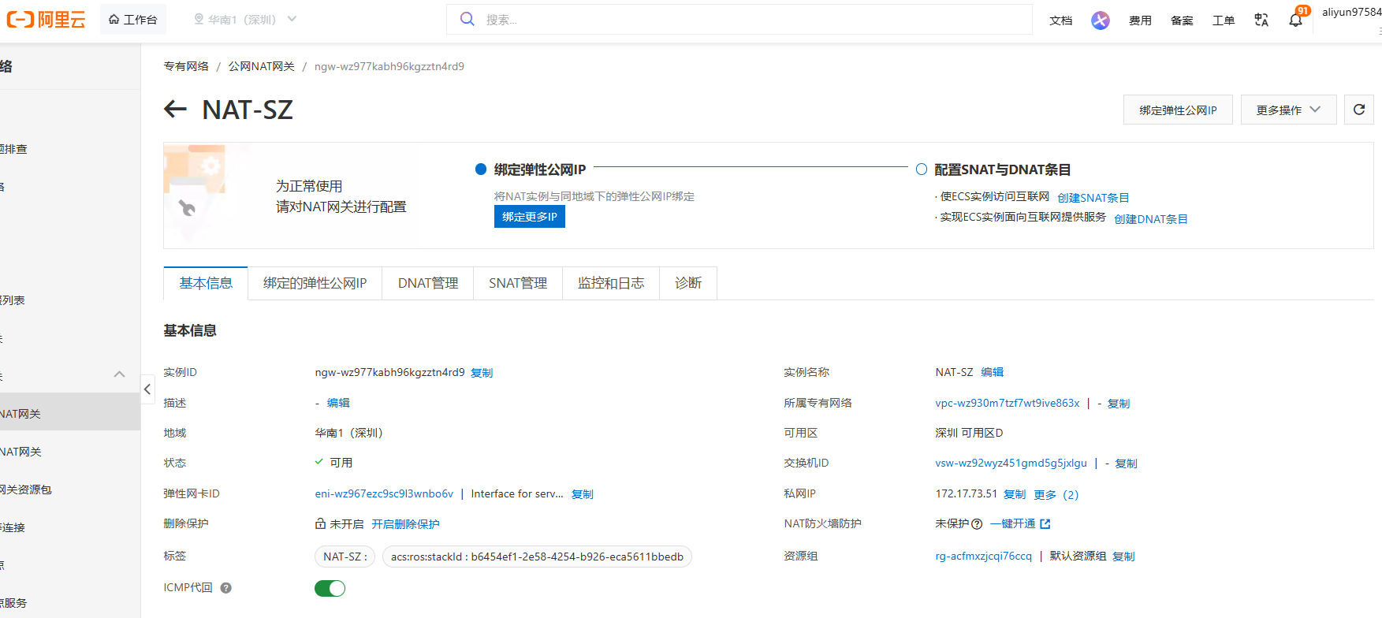
Step 2: After purchasing 2 public IP addresses, we have 39.108.50.174 and 119.23.72.59,
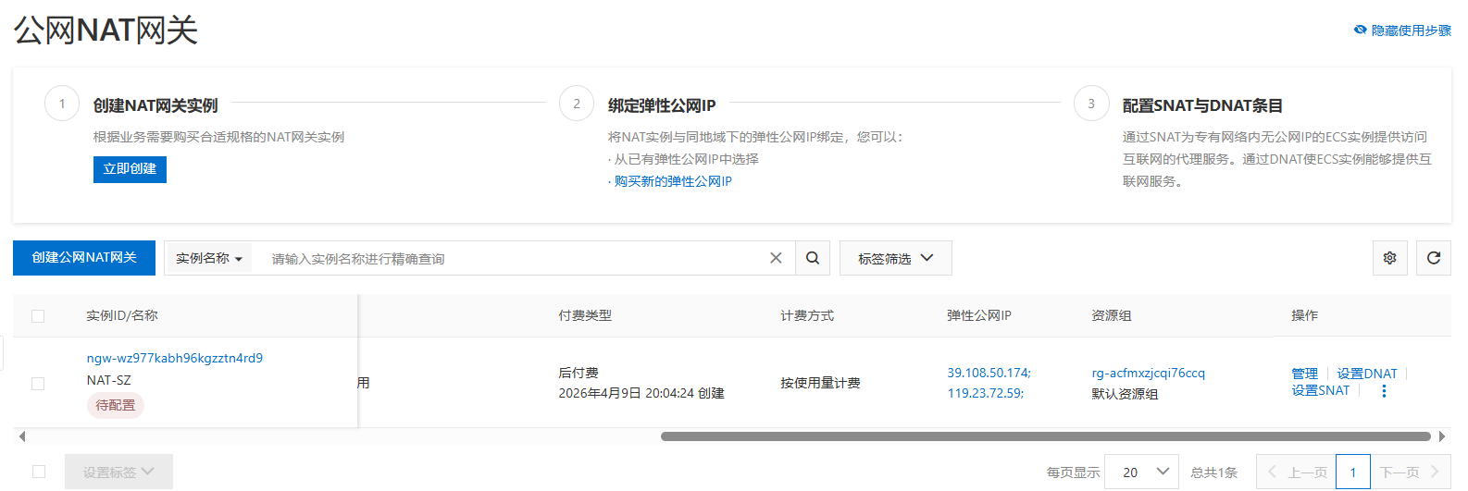

1.3. Purchase Multiple Node on Alibaba Cloud
Step 1: Click https://vpc.console.aliyun.com/vpc/cn-shenzhen/vpcs, purchase another 1 ECS node,
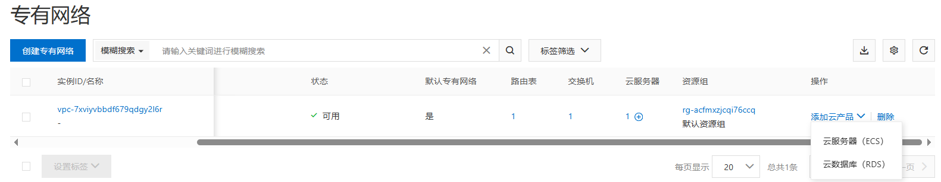
choose pay as you go, choose ecs.c7.2xlarge, choose Ubuntu 16.04 64 bits, choose ESSD, choose no IPv4 address, choose your password Y0urpassword,
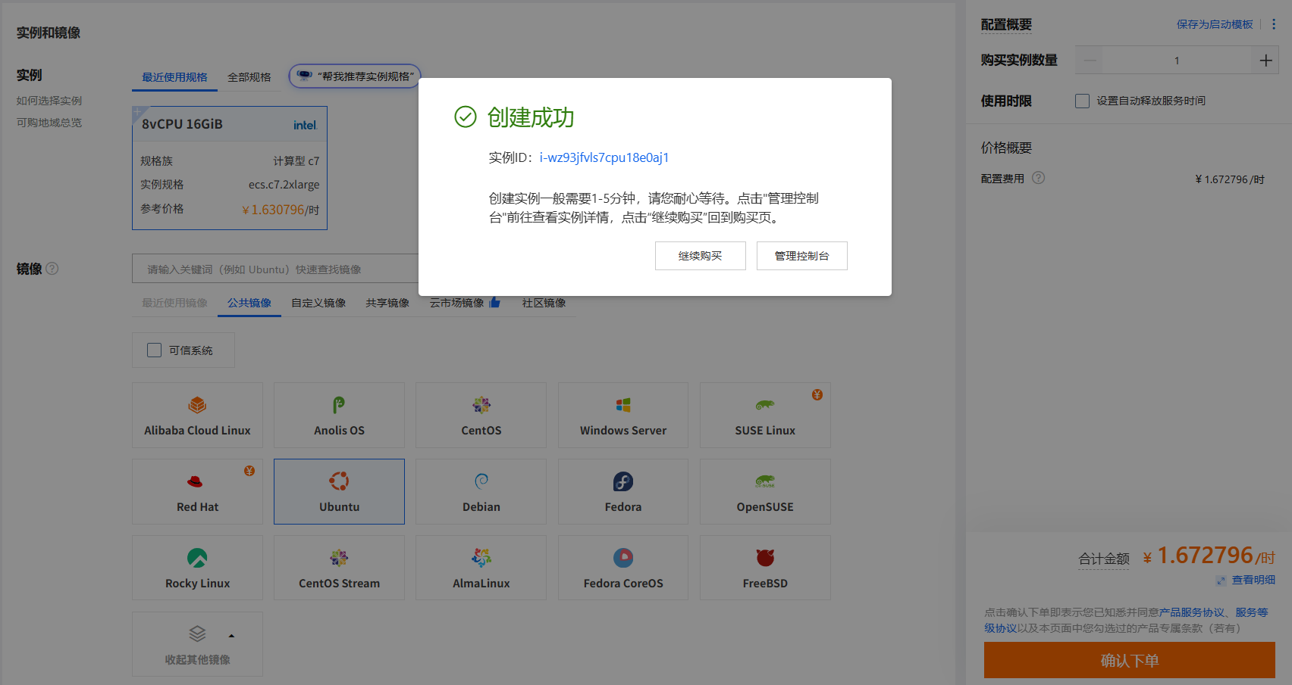

1.4. Configure the NAT Gateway
Step 1: Click https://vpc.console.aliyun.com/nat/cn-shenzhen/nats, configure the NAT gateway, where the IP address 119.23.72.59 for DNAT and 39.108.50.174 for SNAT (DNAT for Internet users and SNAT for VM inside). Currently, we have 1 NAT, 2 Public IP addresses, and 2 ECS, our target is as follows:
For NAT (Public IP):
SNAT | DNAT
39.108.50.174 | 119.23.72.59

For ECS maps (Inside IP):
SNAT | DNAT
- | 172.17.73.50
 | 172.17.73.53

Step 2: Configure the SNAT,
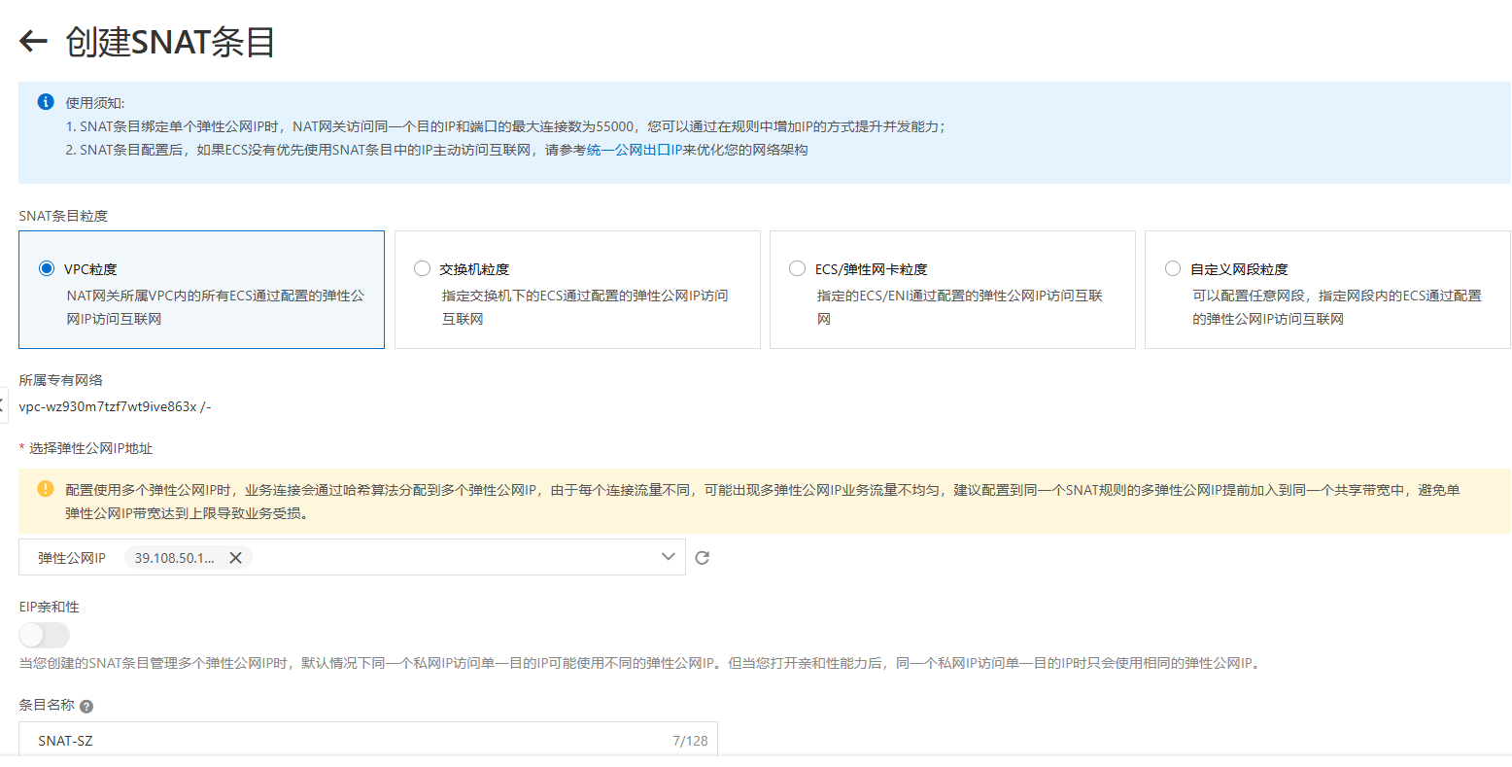

Step 3: Configure the DNAT,
ECS maps:
DNAT Public IP and Port Number | DNAT Inside IP
119.23.72.59:10000 | 172.17.73.50
119.23.72.59:10001 | 172.17.73.53

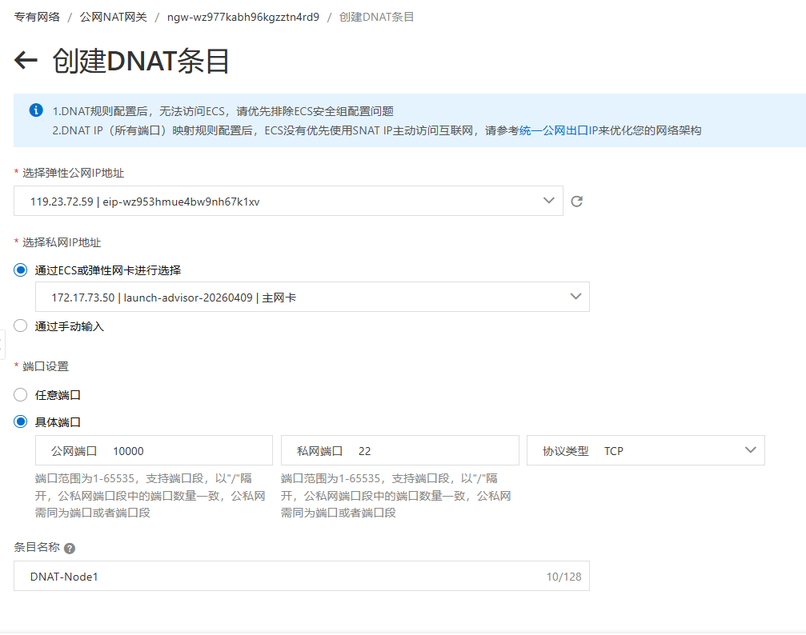
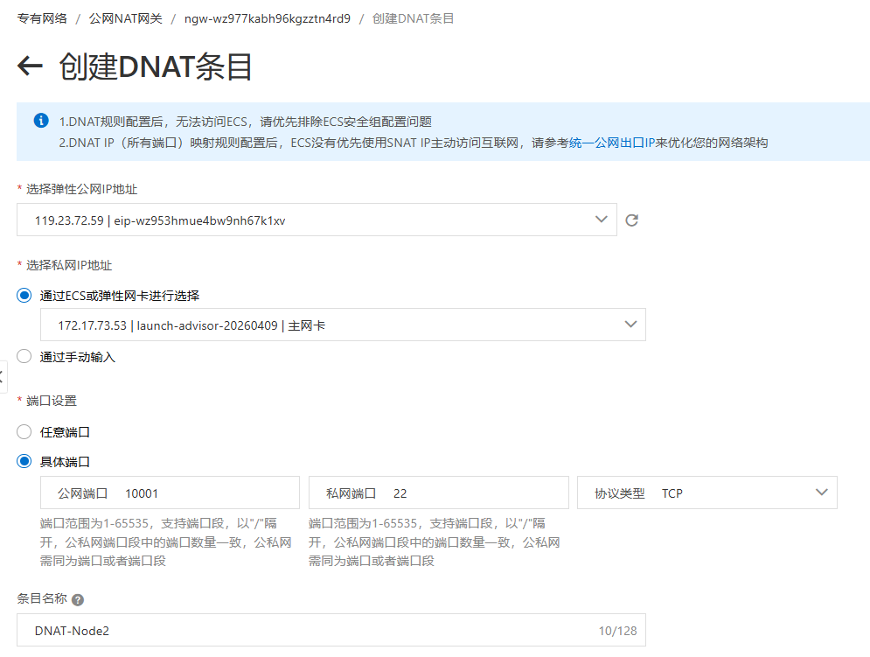
Access the inside IPs via Xshell,
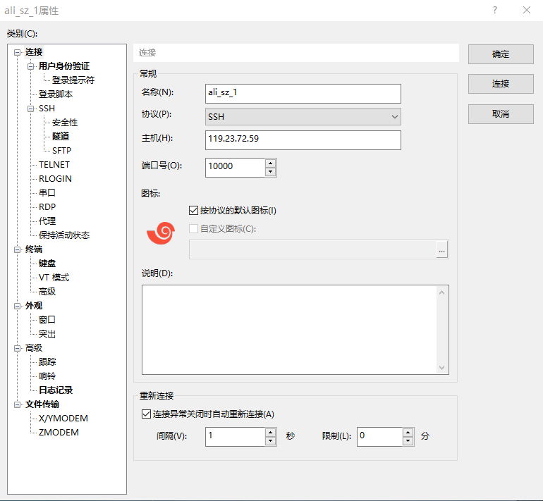
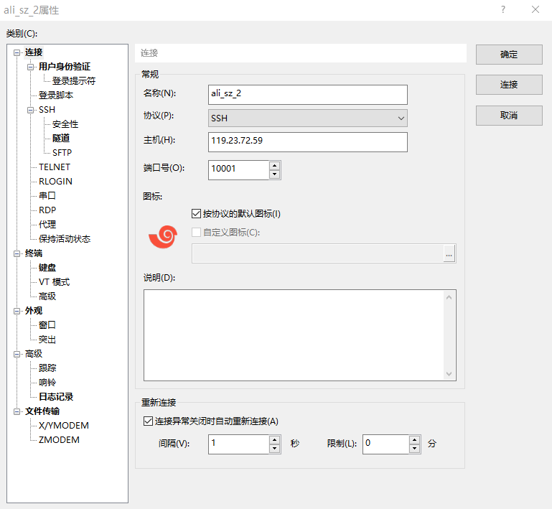

1.5. Configure the password-free SSH
Step 1: The target is as follows,
Host with free-password SSH to
172.17.73.50 | 172.17.73.53

Step 2: Configure the 172.17.73.50,
$ ssh-keygen

$ ssh root@172.17.73.53 'mkdir -p .ssh && cat > .ssh/authorized_keys' < ~/.ssh/id_rsa.pub

$ ssh 172.17.73.53 "echo 'hi'"

1.6. Free the NAT Gateway
Step 1: Click https://vpc.console.aliyun.com/nat/cn-shenzhen/nats/ngw-wz977kabh96kgzztn4rd9/snats, delete SNAT,
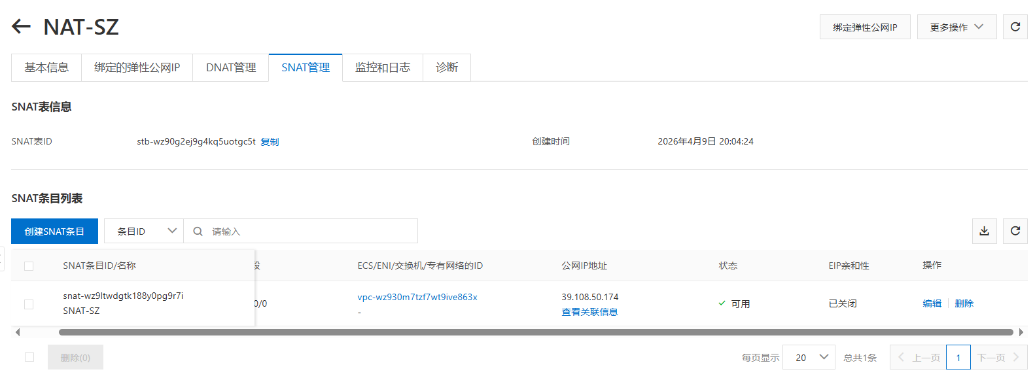
Step 2: Click https://vpc.console.aliyun.com/nat/cn-shenzhen/nats, unbind public IP, free public IP,
Step 3: Click https://homenew.console.aliyun.com/home/dashboard/ProductAndService, delete ECS,
Step 4: Click https://vpc.console.aliyun.com/nat/cn-shenzhen/nats, delete NAT

Run A Bitcoin Full Node

2.1. Set Up A Bitcoin Full Node
Step 1: Follow the official tutorial and install the Bitcoin Core of (bitcoin-28.1),
# cd $HOME/data
# wget https://bitcoincore.org/bin/bitcoin-core-28.1/bitcoin-28.1-x86_64-linux-gnu.tar.gz
# tar -xzvf bitcoin-28.1-x86_64-linux-gnu.tar.gz
# cp $HOME/data/bitcoin-28.1/bin/bitcoind /usr/local/bin
# cp $HOME/data/bitcoin-28.1/bin/bitcoin-cli /usr/local/bin

# cd $HOME/.bitcoin
# vi $HOME/.bitcoin/bitcoin.conf
Step 2: Configure Bitcoin Core with the configuration of ‘txubdex=1’ such that a full transaction index is maintained,
// Configure $HOME/.bitcoin/bitcoin.conf
server = 1
txindex = 1
daemon = 1
rpcuser = User
rpcpassword = Y0urpassword
maxmempool = 3000000000
datadir = /root/data/bitcoindata
Step 3: Run the Bitcoin Full node,
# bitcoind
Step 4: Check whether bitcoin core has been set up successfully,
$ bitcoin-cli –version

$ bitcoin-cli getblockcount

(a): Bitcoin official tutorial (GUI-based) is: https://bitcoin.org/en/full-node#costs-and-warnings
Step 1 (b): Bitcoin tutorial (Command Line-based) is: https://bitcoincore.org/bin/ and https://onela.cn/posts/zh/2024-05-23-ubuntu%E4%B8%8B%E6%90%AD%E5%BB%BAbitcoin%E5%85%A8%E8%8A%82%E7%82%B9%E5%AE%89%E8%A3%85%E9%83%A8%E7%BD%B2/
# wget https://bitcoincore.org/bin/bitcoin-core-28.1/bitcoin-28.1-x86_64-linux-gnu.tar.gz
# tar -xzvf bitcoin-28.1-x86_64-linux-gnu.tar.gz
# sudo install -m 0755 -o root -g root -t /usr/local/bin bitcoin-28.1/bin/*

# mkdir -p /data/bitcoin

Disk size
# df -hl
/dev/vda1 1.5T 2.2G 1.5T 1% /

2.2. Instals
Step 1: In node

